How to test APIs in Postman
(1) API ROOT [Optional]
http://127.0.0.1:8000/api/
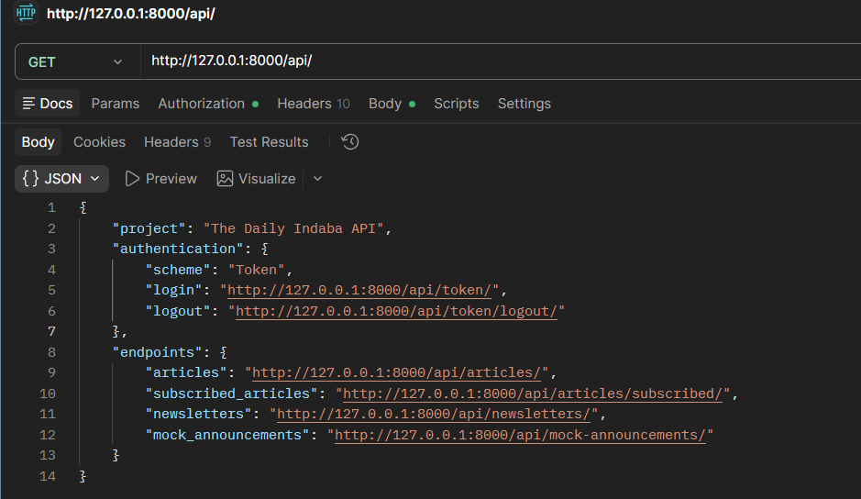

(2) Obtain a token:
http://127.0.0.1:8000/api/token/
{
"username": "lerato.maseko",
"password": "demo1234"
}
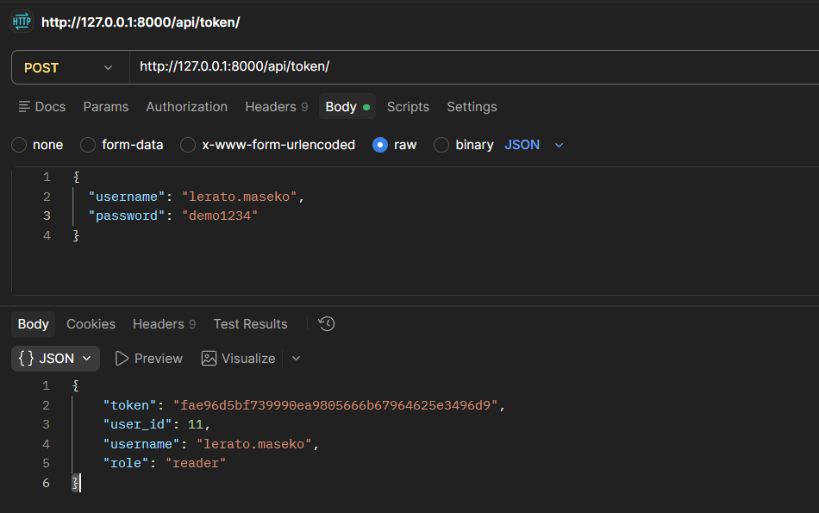

(3) Use DRF token auth, not Basic Auth:
http://127.0.0.1:8000/api/articles/
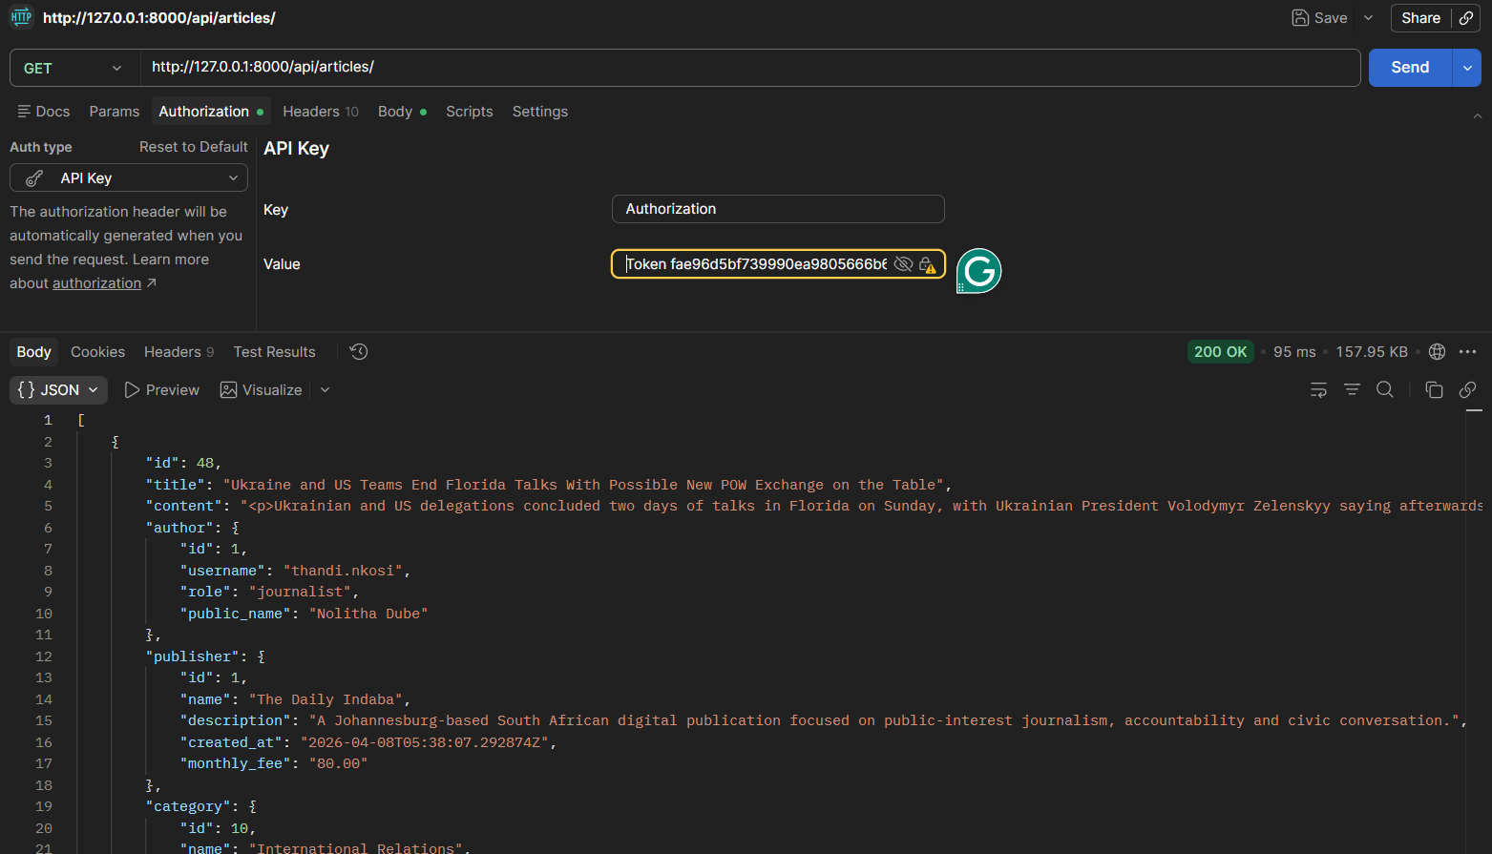
Note: The word “Token” must appear before the Token itself!!!

(4) READER LISTS ARTICLES:
http://127.0.0.1:8000/api/articles/subscribed/

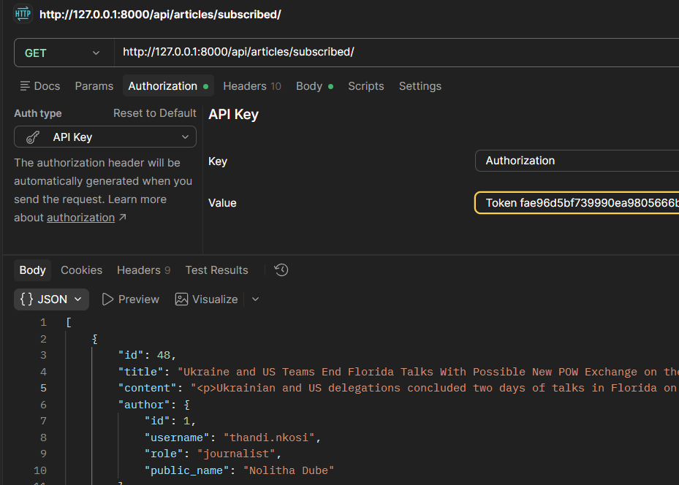

(5) READER LISTS NEWSLETTERS
http://127.0.0.1:8000/api/newsletters/
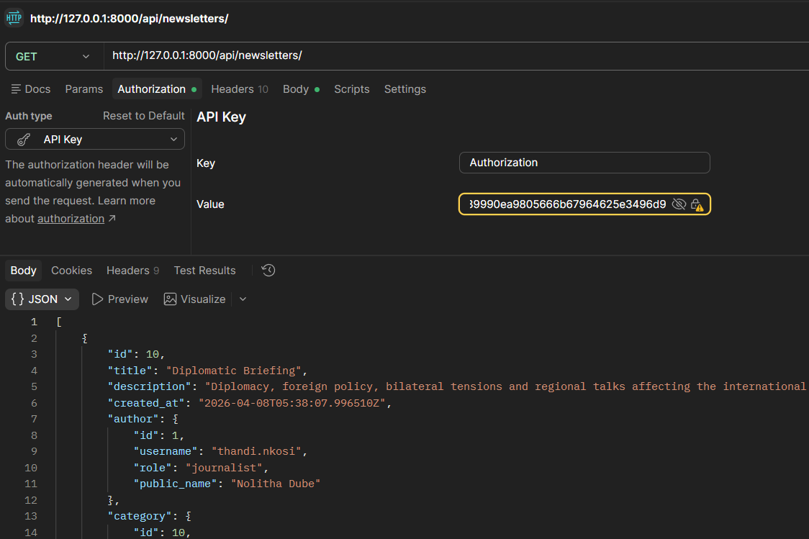

(6) READER TRIES TO CREATE AN ARTICLE
http://127.0.0.1:8000/api/articles/
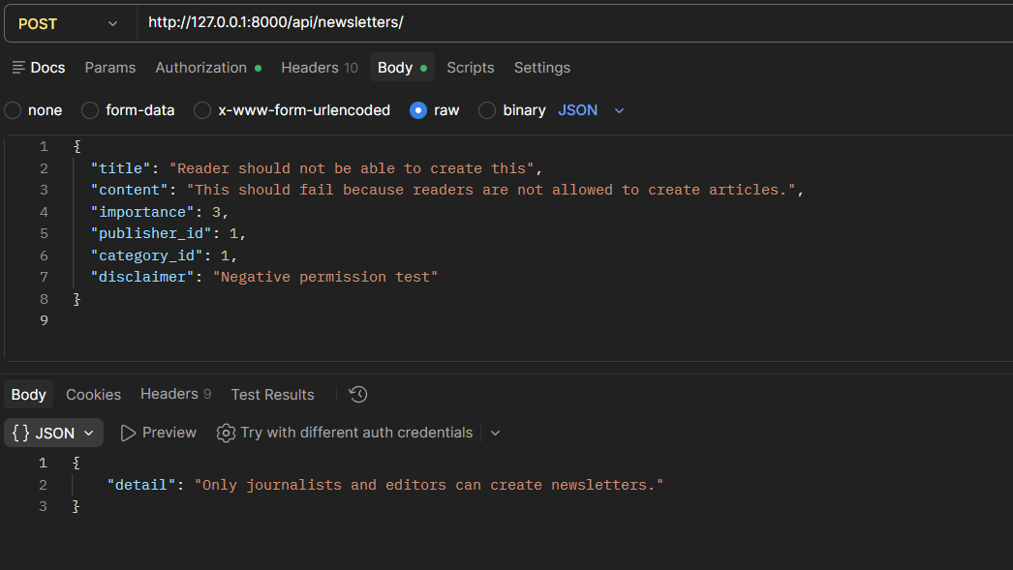

(7) LOG IN AS JOURNALIST
http://127.0.0.1:8000/api/token/
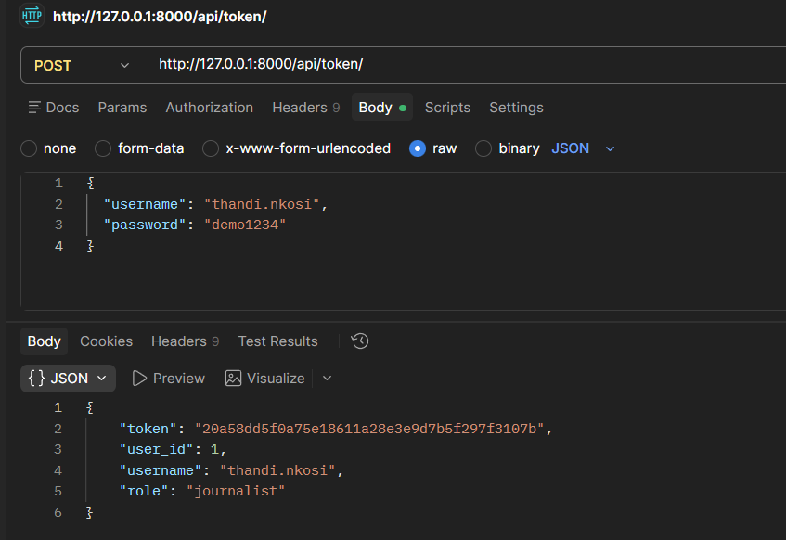
NB.: Copy token & use in API Key authentication:
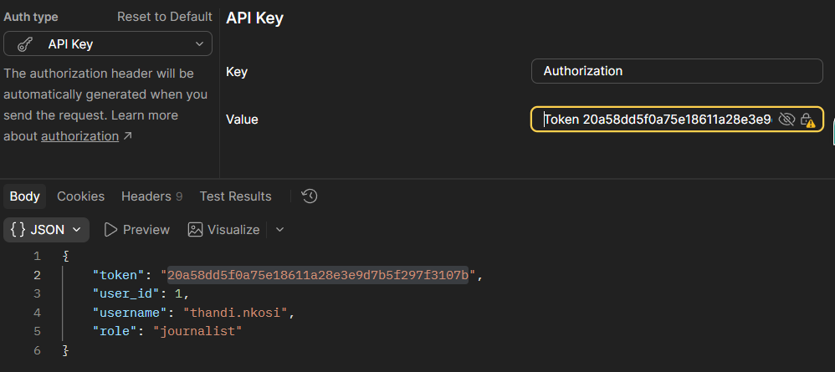

(8) JOURNALIST LISTS ARTICLES TO FIND REAL IDS
http://127.0.0.1:8000/api/articles/

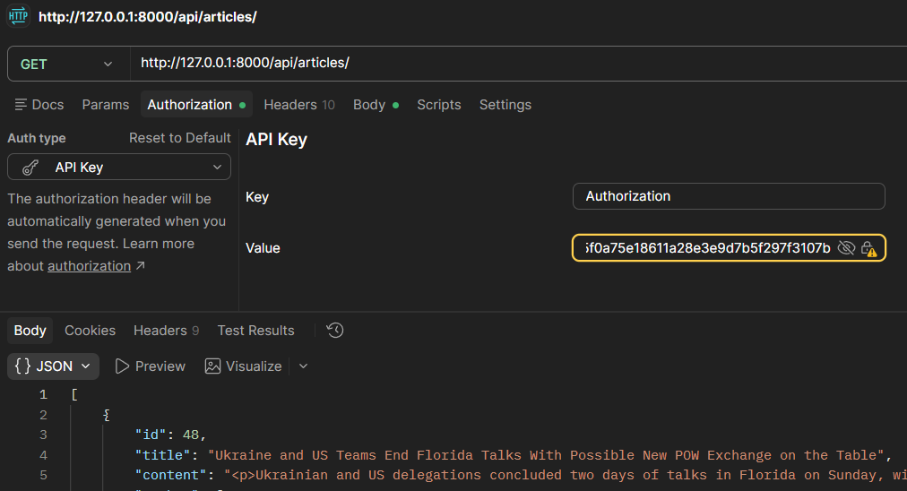

(9) JOURNALIST CREATES A NEW ARTICLE
http://127.0.0.1:8000/api/articles/
{
"title": "Postman test article",
"content": "Opening sentence for the teaser. This second sentence is here so you can see full content behaviour after approval.",
"importance": 3,
"publisher_id": 1,
"category_id": 1,
"disclaimer": "Created manually in Postman"
}
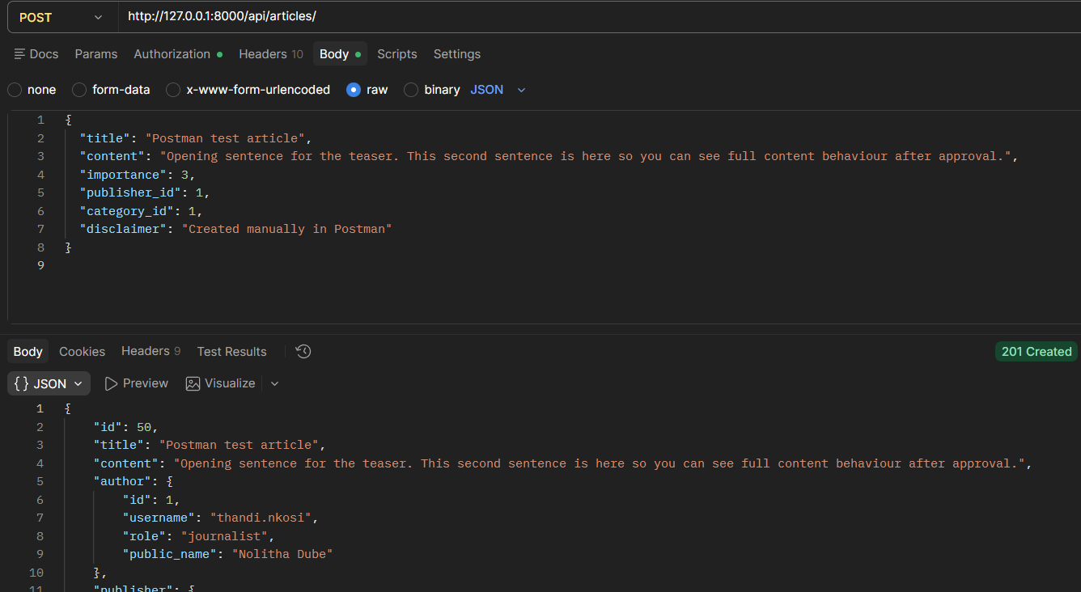

(10) - JOURNALIST RETRIEVES THAT ARTICLE
http://127.0.0.1:8000/api/articles/1/
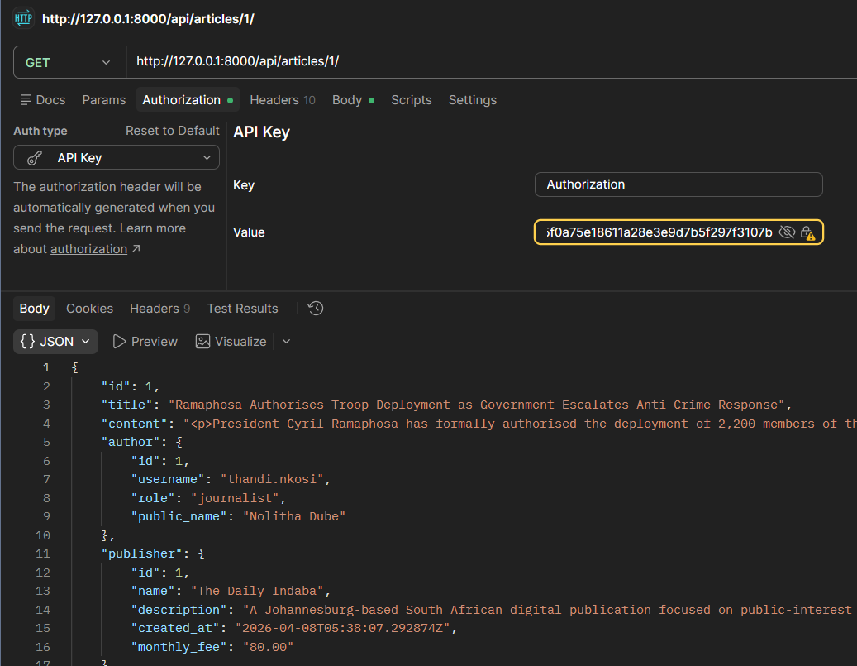

(11) (a) - JOURNALIST FULLY UPDATES OWN PENDING ARTICLE
http://127.0.0.1:8000/api/articles/50/
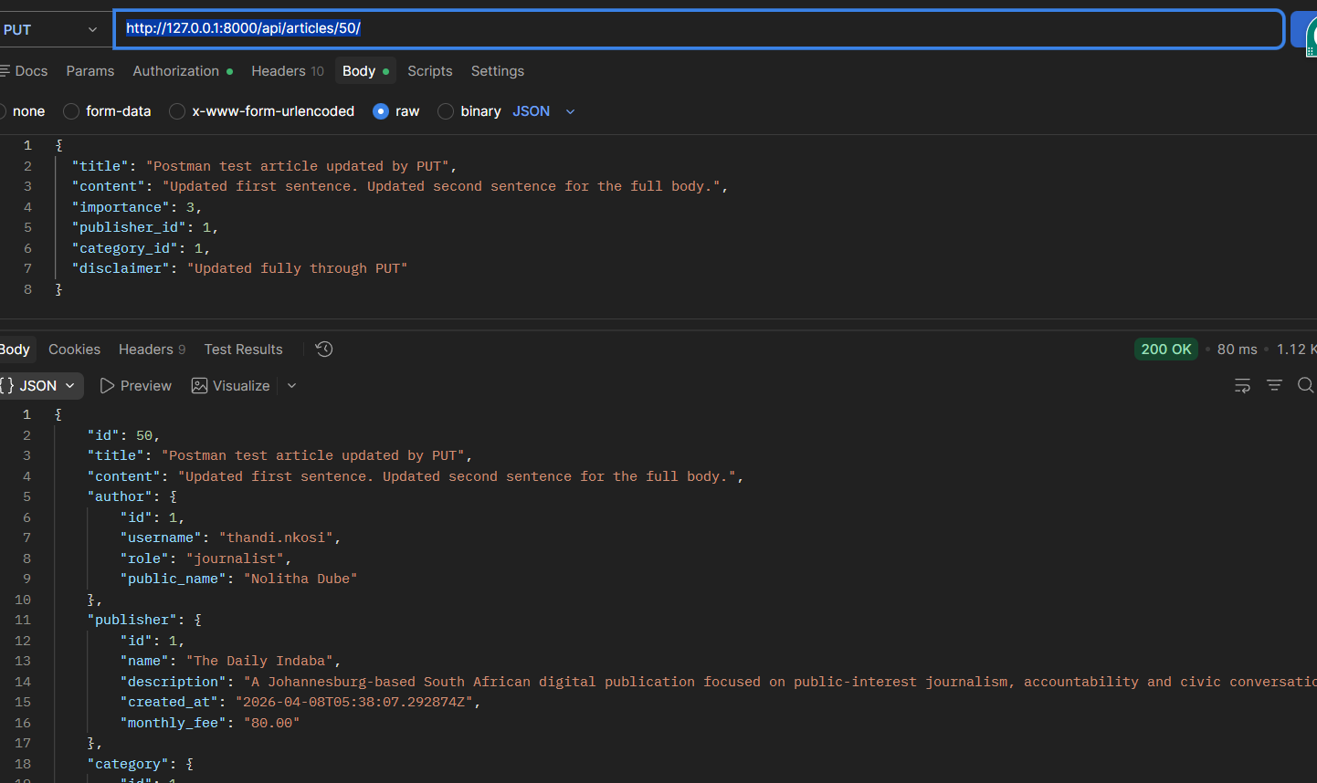

(11) (b) - JOURNALIST TRIES TO UPDATE APPROVED ARTICLE
http://127.0.0.1:8000/api/articles/1/
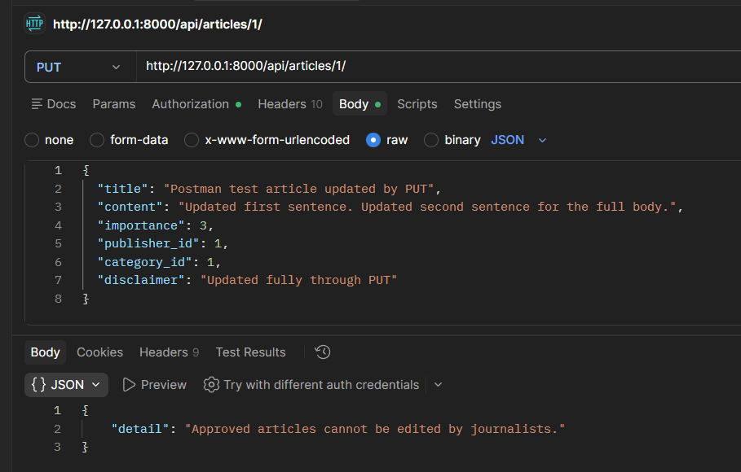

(12) - LOG IN AS EDITOR
http://127.0.0.1:8000/api/token/
{
"username": "nomusa.khumalo",
"password": "demo1234"
}
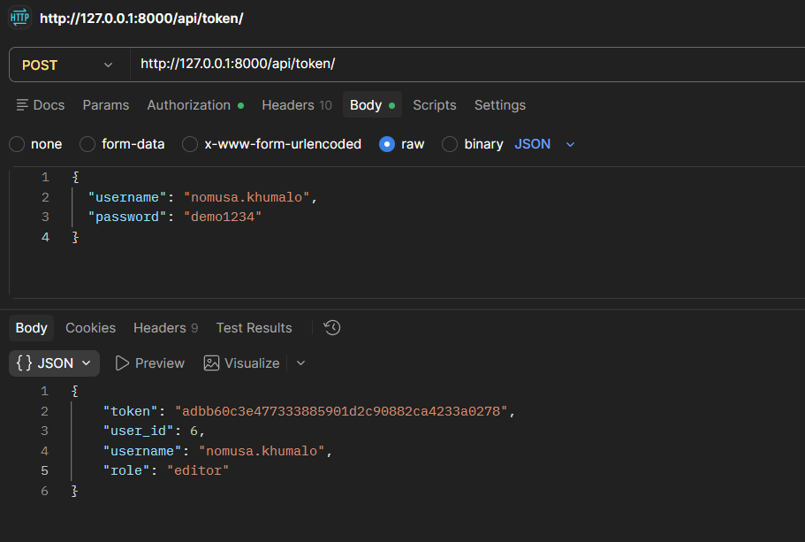
NB.: Copy token & use in API Key authentication:
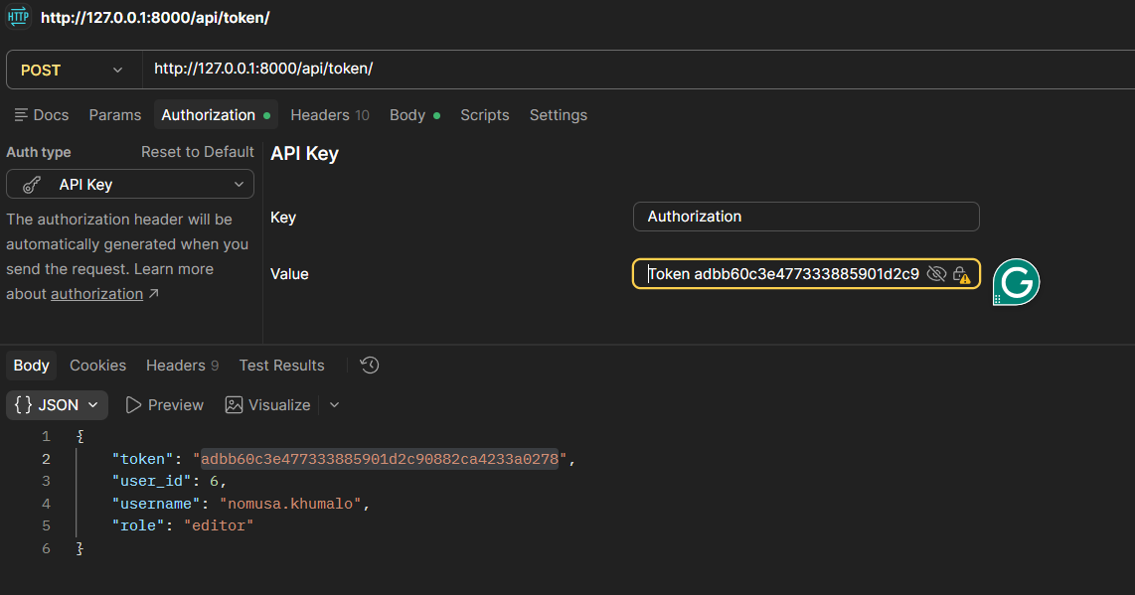

(13) EDITOR PARTIALLY UPDATES THE PENDING ARTICLE
http://127.0.0.1:8000/api/articles/50/
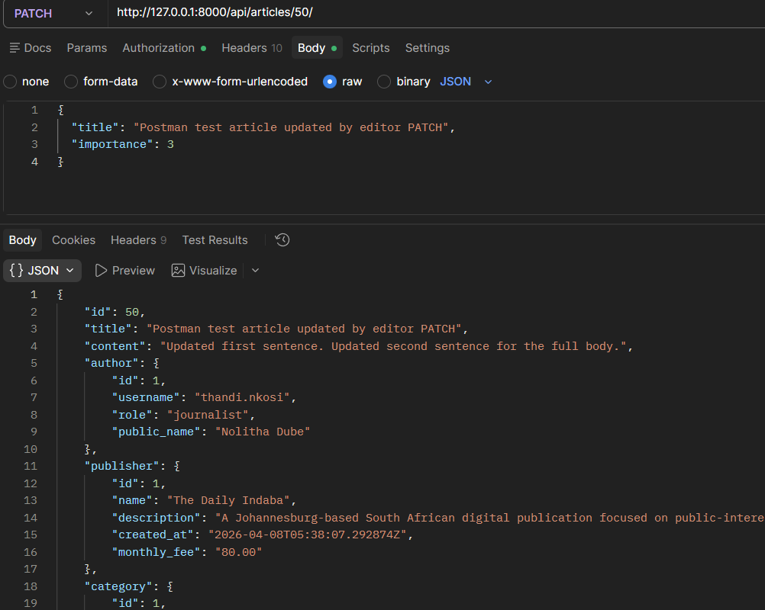

(14) EDITOR APPROVES THE ARTICLE
http://127.0.0.1:8000/api/articles/50/approve/
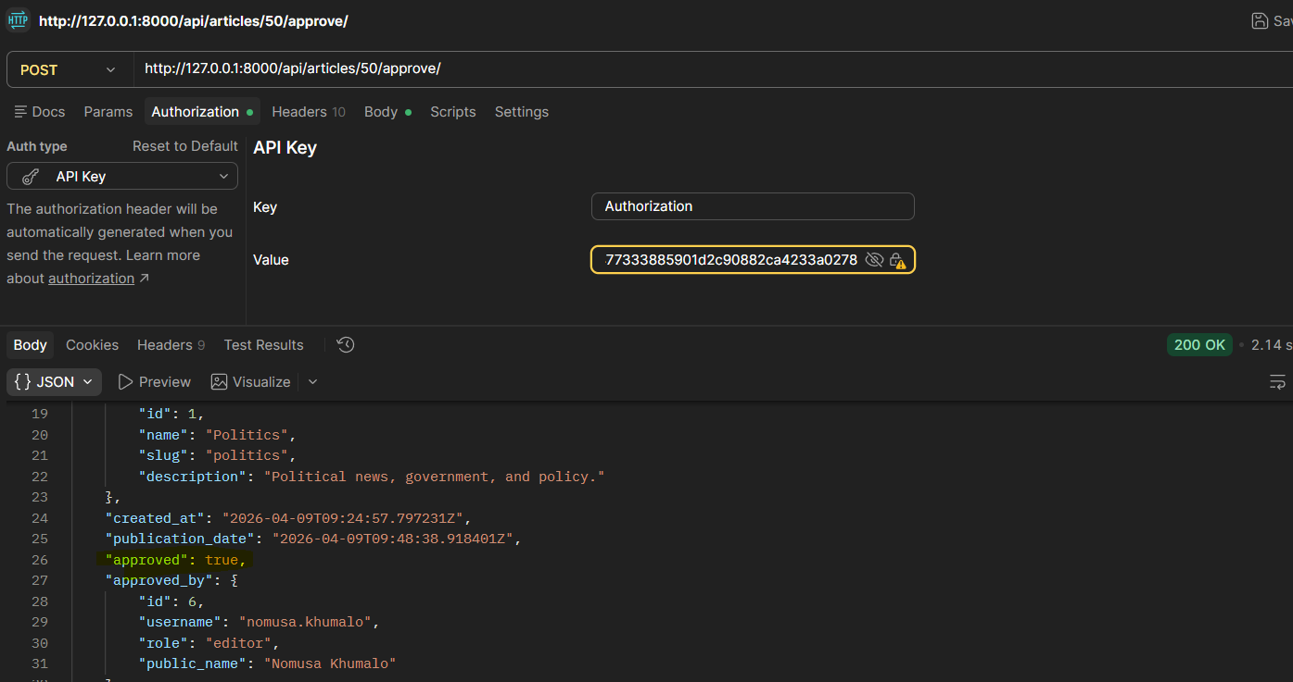

MOCK ANNOUNCEMENT:
http://127.0.0.1:8000/api/mock-announcements/
{
"announcement_type": "article_approval",
"article_id": 1,
"title": "Test Article",
"article_url": "http://127.0.0.1:8000/daily-indaba/articles/50/",
"author": "Test Author",
"kind": "link"
}
